**Q.1 . Suppose you have been given the table structure and data shown in Table P5.27, which was imported from an Excel spreadsheet. The data reflect that a professor can have multiple advisees, can serve on multiple committees, and can edit more than one journal.**

|  |
| --- |
| **ATTRIBUTE NAME SAMPLE VALUE SAMPLE VALUE SAMPLE VALUE SAMPLE VALUE** |
| **EMP_NUM 123 104 118** |
| **PROF_RANK Professor Asst. Professor Assoc. Professor Assoc. Professor** |
| **EMP_NAME Ghee Rankin Ortega Smith** |
| **DEPT_CODE CIS CHEM CIS ENG** |
| **DEPT_NAME Computer Info. Chemistry Computer Info. English Systems Systems** |
| **PROF_OFFICE KDD-567 BLF-119 KDD-562 PRT-345** |
| **ADVISEE 1215, 2312, 3233, 3102, 2782, 3311, 2218, 2098 2008, 2876, 2222,**  **3745, 1783, 2378**  **2134, 2789, 3456, 2873, 2765, 2238, 2002, 2046, 2018, 2901, 2308 2764** |
| **COMMITTEE_CODE PROMO, TRAF, DEV SPR, TRAF PROMO, SPR, APPL, DEV DEV** |
| **JOURNAL_CODE JMIS, QED, JCIS, JMGT JMGT** |

**Given the information in**

1. **Draw the dependency diagram.**
2. **Create the dependency diagrams to yield a set of table structures in 3NF.**

**Q.2**

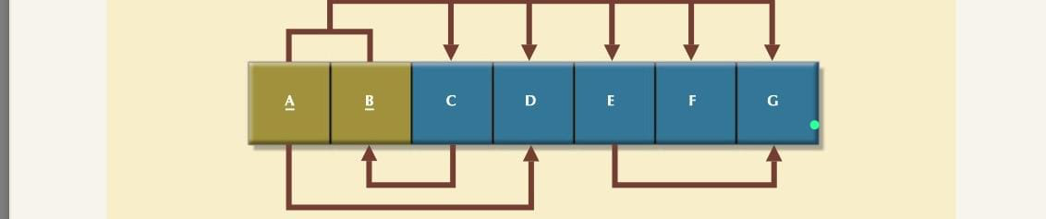

1. Break up the dependency diagram shown in above figure to create two new dependency diagrams, one in 3NF and one in 2NF.
2. Modify the dependency diagrams you created in a) to produce a set of dependency diagrams that are in 3NF. To keep the entire collection of attributes together, copy the 3NF dependency diagram from Problem 2; then show the new dependency diagrams that are also in 3NF. (*Hint*: One of your dependency diagrams will be in 3NF but not in BCNF.)
3. Modify the dependency diagrams you created in b) to produce a collection of dependency diagrams that are in 3NF and BCNF.

Q.3 Suppose you are given the following business rules to form the basis for a database design. The database must enable the manager of a company dinner club to mail invitations to the club’s members, to plan the meals, to keep track of who attends the dinners, and so on.

* + Each dinner serves many members, and each member may attend many dinners.
  + A member receives many invitations, and each invitation is mailed to many members.
  + A dinner is based on a single entree, but an entree may be used as the basis for many dinners. For example, a dinner may be composed of a fish entree, rice, and corn. Or the dinner may be composed of a fish entree, a baked potato, and string beans.
  + A member may attend many dinners, and each dinner may be attended by many members.  
    Because the manager is not a database expert, the first attempt at creating the database uses the structure shown in Table

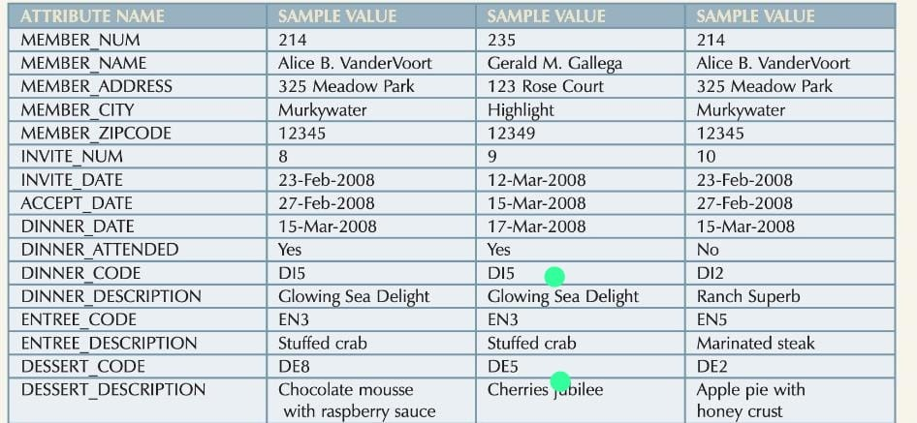

Given the table structure above, write the relational schema and draw its dependency diagram. Label all transitive and/or partial dependencies. (*Hint*: This structure uses a composite primary key.) Break up the dependency diagram that are in 3NF and write the relational schema.

Q.4 To keep track of office furniture, computers, printers, and so on, the FOUNDIT company uses the table structure shown below:-

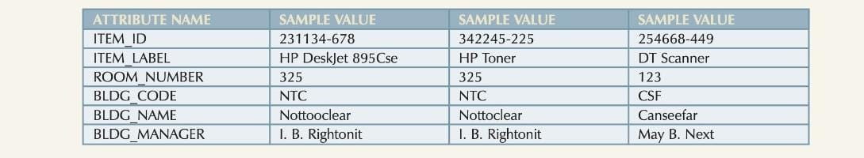

Given that information, write the relational schema and draw the dependency diagram. Make sure that you label the transitive and/or partial dependencies. Write the relational schema and create a set of dependency diagrams that meet 3NF requirements.